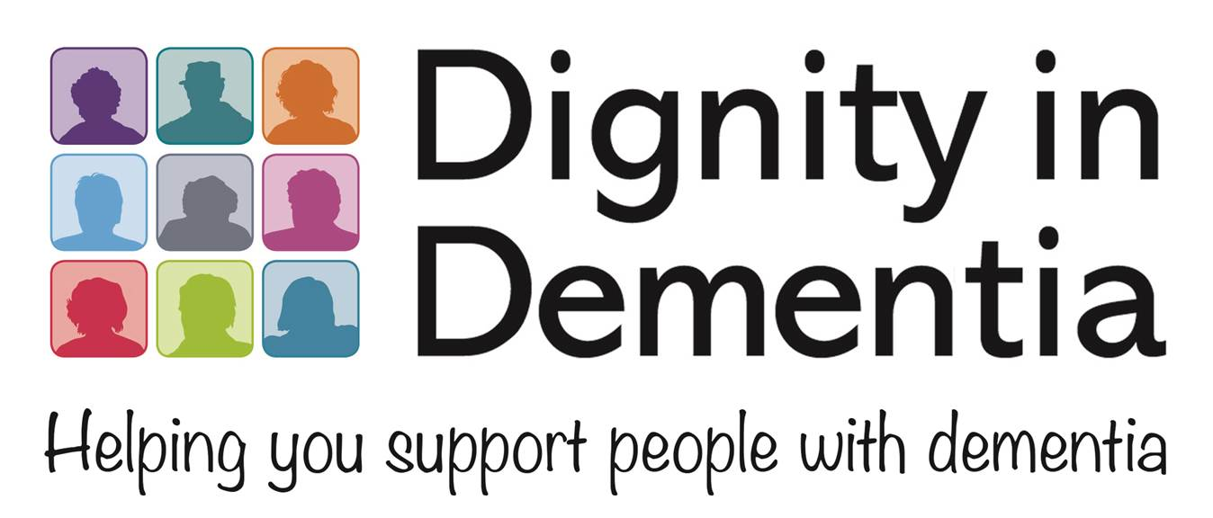

COMMUNITY COME DANCING
SESSION DATES 2018

Thursdays between 1.30 – 2.30 pm

January 25th
February 8th
February 22nd
March 8th
March 22nd
April 19th
May 3rd
May 17th
June 7th
June 21st
July 5th
July 19th
Sept 6th
Sept 20th
Oct 4th
Oct 18th
Nov 1st
Nov 15th
Nov 29th
Dec 13th

